Number Eight (Module One)
Robert’s Rules of Order
- The meeting I attended is, the Student Council meeting
Student Council Meeting
- Agenda
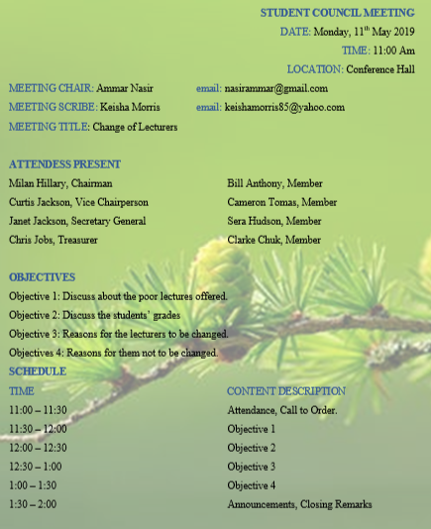

- Checklist
Robert’s rules observed | Robert’s Rules not observed
Call to order | Reports of officers
Approval of minutes | Reports of the standing committee
New business | Reports of a special committee
Announcement
Adjourn

- The meeting was discussing the overall poor grades of all students across all the faculties in the University. They were looking for root causes of the bad grades and they came to an agreement that the current lecturers were not doing good work on their side.
- The meeting, after finding out the root cause of the poor grades, they resolved that they were going to report the matter to the heads of the institution, who would then figure out the action to take.

